# CS 255 System Design Document Template

## UML Diagrams

### UML Use Case Diagram

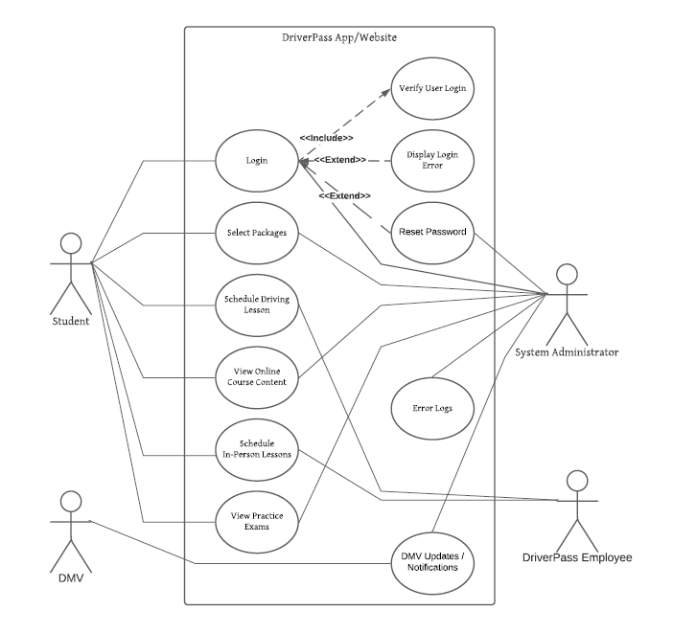

### UML Activity Diagrams

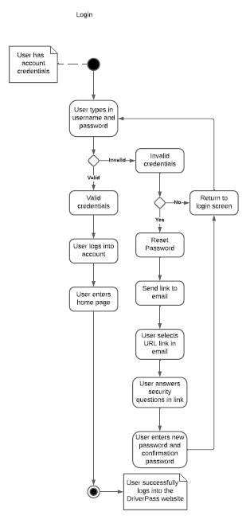

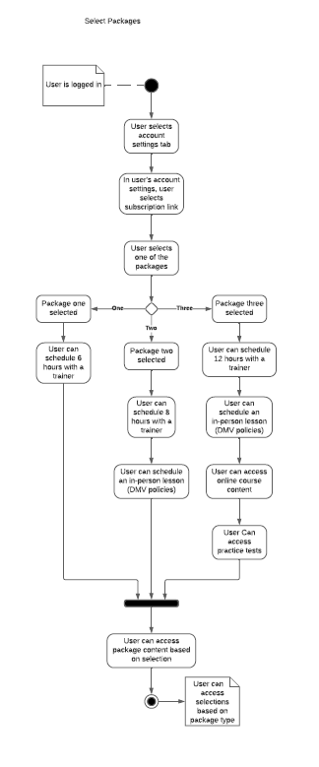

### UML Sequence Diagram

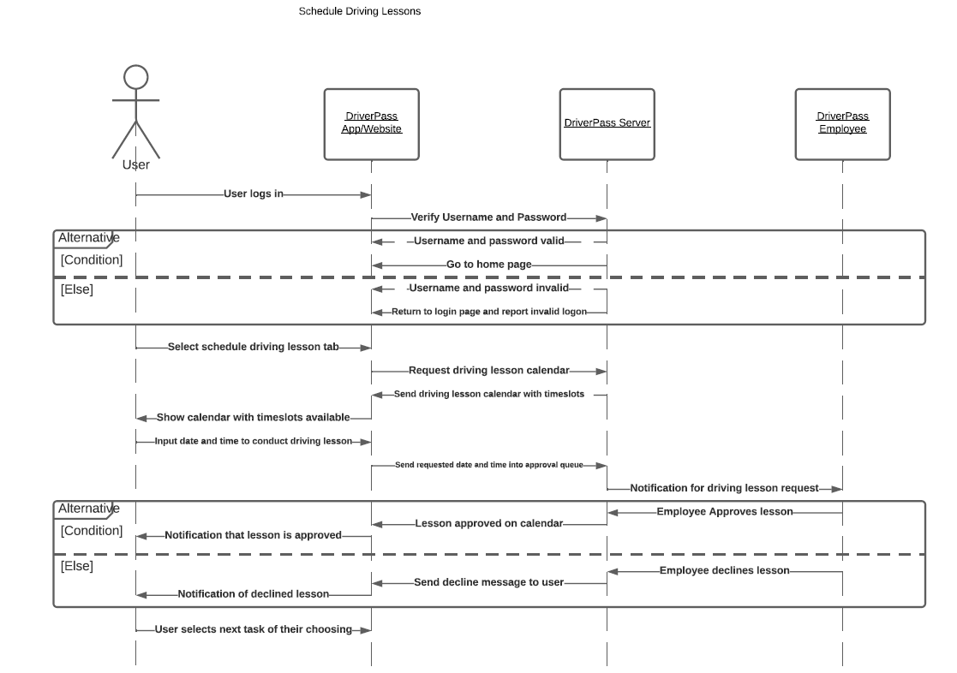

### UML Class Diagram

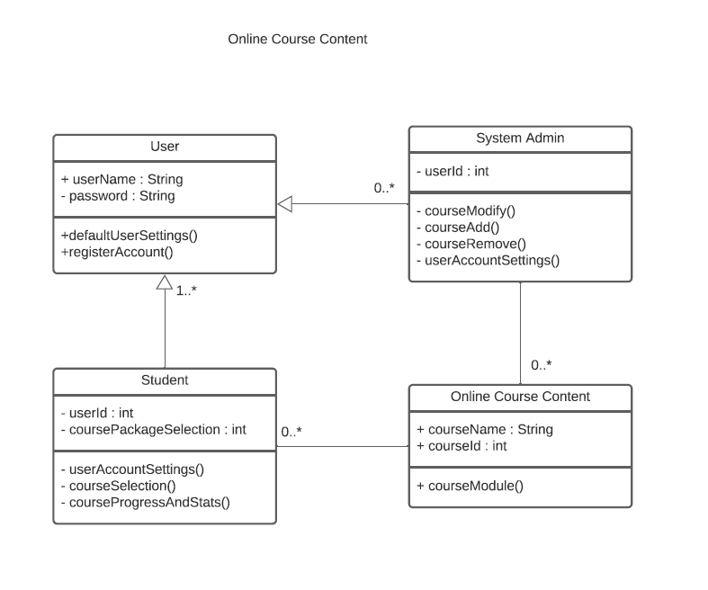

## Technical Requirements

There are several technical requirements that are necessary for this system to work properly. One major requirement is having a modern personal computer, mobile device, or a tablet to allow functionality of the operating system, the application, and the network connection. Next is the operating system, it is recommended to have an up to date version to utilize the latest browsers and application supporting tools. In addition, it is vital to have a supporting browser to allow the functionality of the website portion of the DriverPass system. For portable devices, they will need to download the application that supports the mobile features of the DriverPass system. Which will require having an internet connection to be able to access the online portions of this system. In conclusion, these technical requirements are vital for the system to be fully functional for the user.